**The Electromagnetic Spectrum**

**Go to the NASA website** <https://science.nasa.gov/ems>

**Click on ‘*Introduction to the Electromagnetic Spectrum’***

1. How does electromagnetic energy travel?
2. Name 3 everyday activities that involve electromagnetic energy.
3. Fill in the missing labels on the electromagnetic spectrum.

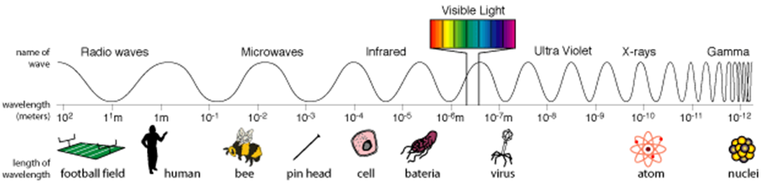

**At the bottom of the webpage, click on *‘Next: Anatomy of an Electromagnetic wave’***

1. In your own words, describe electromagnetic waves.
2. What was the theory that James Clerk Maxwell developed?
3. What was Heinrich Hertz’s contribution to our understanding of waves?

1. Explain what is meant by frequency. Include a diagram as part of your description.
2. Explain what is meant by wavelength. Include a diagram as part of your description.

**At the bottom of the webpage, click on *‘Next: Wave Behaviours’***

1. Light waves in the electromagnetic spectrum behave in similar ways. Briefly summarise each of the wave behaviours below:
   1. Reflection
   2. Absorption
   3. Diffraction
   4. Scatter
   5. Refraction

**At the bottom of the webpage, click on *‘Radio waves’***

1. Radio waves have the ***longest/shortest*** wavelengths in the electromagnetic spectrum.
2. What range of lengths can radio waves have?
3. Give three uses for radio waves.
4. Radio telescopes are used to study planets, comets, stars and galaxies.
   1. What are astronomers able to learn by studying the radio waves from these objects?
   2. What is an advantage of radio astronomy?

**At the bottom of the webpage, click on *‘Next: Microwaves’***

1. Explain how microwaves are used to cook food.
2. List some uses for microwaves.
3. Why are microwaves good for transmitting information from one place to another?
4. How is active remote sensing different to passive remote sending?

**At the bottom of the webpage, click on *‘Next: Infrared Waves’***

1. How do we experience infrared waves?
2. William Herschel discovered infrared waves. Describe the experiment he conducted which led him to this discovery.
3. Describe one use for infrared waves.

**At the bottom of the webpage, click on *‘Visible Light’***

1. How are we able to see visible light?
2. Each colour of visible light has a different wavelength.
   1. Which colour has the shortest wavelength?
   2. Which colour of light has the longest wavelength?
3. Explain the relationship between colour and temperature.

**At the bottom of the webpage, click on *‘Next: Ultraviolet Waves’***

1. What type of organisms can see ultraviolet light?
2. Earth Scientists subdivide UV light into UV-A, UV-B and UV-C. How are UV-B rays harmful to humans?
3. What does the Earth’s atmosphere do to UV light?
4. Describe the experiment conducted by Johann Ritter used to prove the existence of ultraviolet light.

**At the bottom of the webpage, click on *‘Next: X-rays’***

1. What happens to the energy of light as its wavelength decreases?
2. Why do we normally talk about x-rays in terms of energy rather than wavelength?
3. State when and by whom X-rays were first discovered? What did he find?
4. Describe how x-ray images are taken of parts of your body.

**At the bottom of the webpage, click on *‘Next: Gamma rays***

1. Describe the wavelength and energy of gamma rays.
2. What types of objects produce gamma rays?